M.PRAVEEN REDDY 2400032662
GITHUB:PraveenReddy-06/Full-Stack-Lab

#SKILL - 8 ➔ Spring Boot – JPQL & Query Methods Module
Prerequisites:
- Basic Idea on Spring Boot and Spring Data JPA
- Knowledge of writing derived query methods

An e-commerce application needs a product search feature where users can view products by category, filter items within a price range, and sort products by price. The backend team must implement these operations using Spring Data JPA, including derived query methods and JPQL queries, to fetch data efficiently without writing long SQL statements.

Your task is to build a product search module that supports category-based search, price filtering, and sorting using Spring Data JPA.

Tasks:
  - Create a Product entity with the following fields: a. id
    - name
    - category
    - price
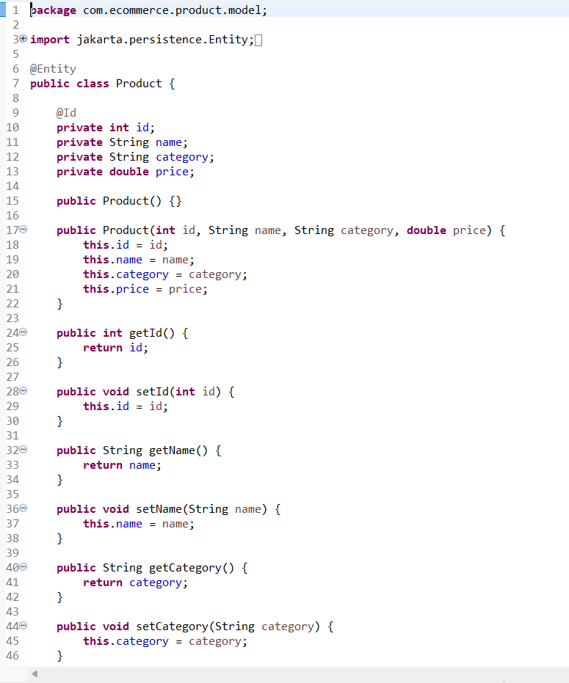
  - Create a ProductRepository and add derived query methods:
    - findByCategory(String category)
    - findByPriceBetween(double min, double max)
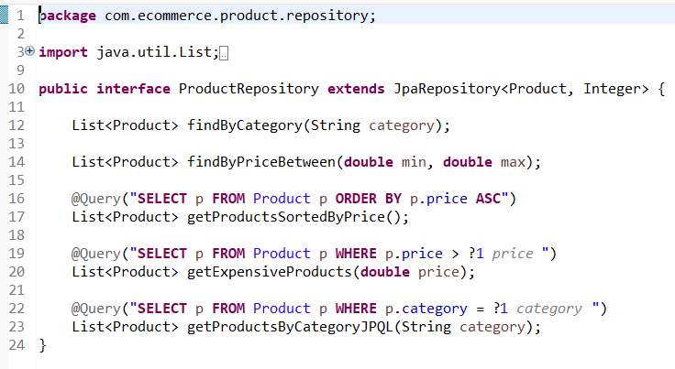
  - Write JPQL queries using @Query for:
    - Sorting products by price
    - Fetching products above a price value
    - Fetching products by category

  - Create REST controller endpoints to test query methods:
    - /products/category/{category}
    - /products/filter?min=&max=
    - /products/sorted
    - /products/expensive/{price}
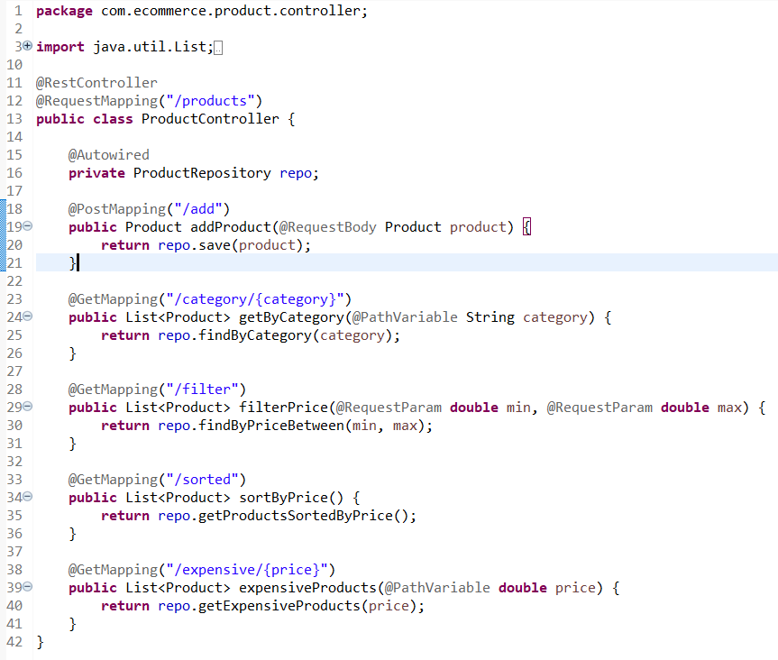
  - Insert sample product records and test using Postman.
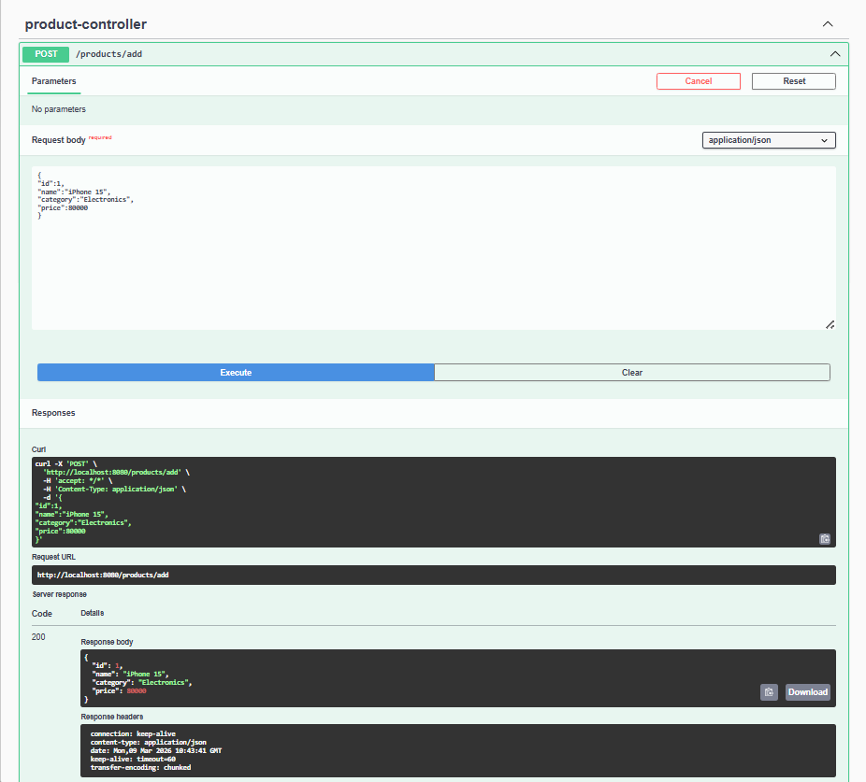
  - Verify output for different categories, ranges, and price values.
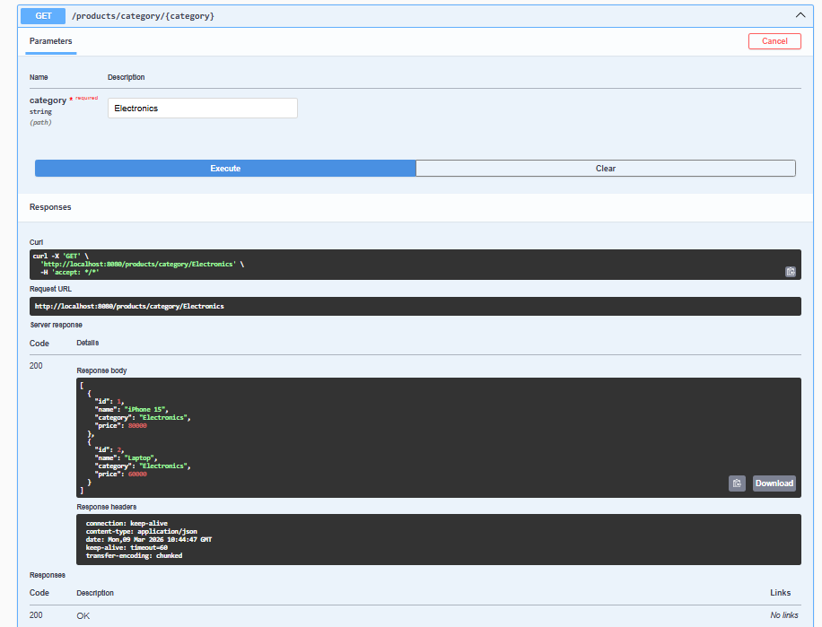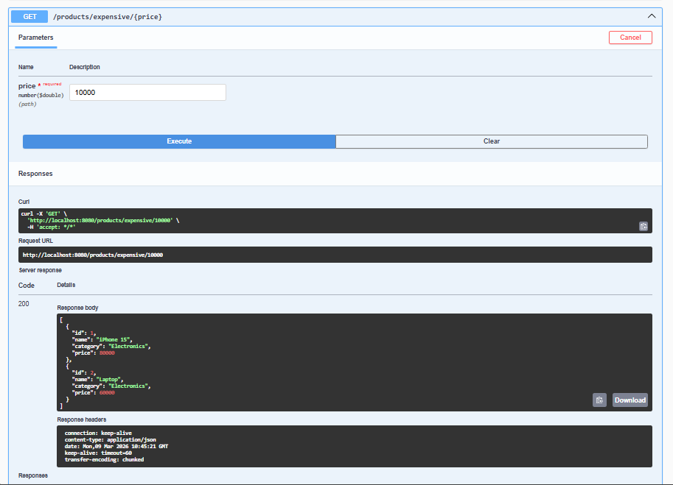
  - Push the Spring Boot project to GitHub.
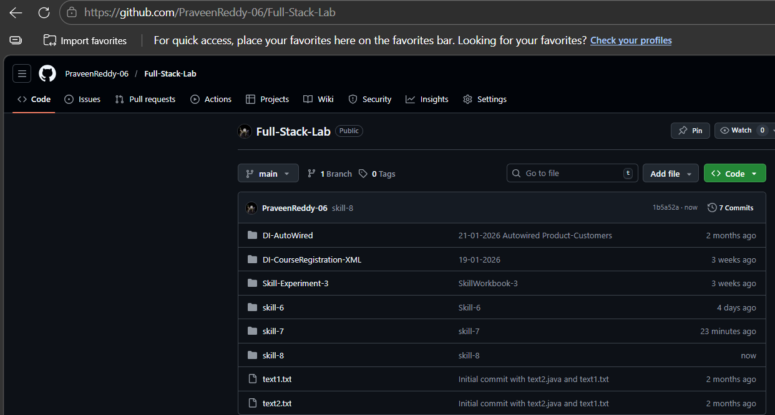
VIVA QUESTIONS:

1. What is JPQL and how is it different from SQL?
JPQL (Java Persistence Query Language) is a query language used to query entity objects in JPA, while SQL queries database tables directly.
2. What are derived query methods in Spring Data JPA?
Derived query methods are queries automatically generated by Spring Data JPA based on the method name.
Example:
findByCategory(String category)

3. Why is method naming important in Spring Data JPA?
Spring Data JPA parses the method name to automatically generate the correct database query.

4. Can JPQL return custom objects in a query?
Yes. JPQL can return custom DTO objects using constructor expressions.
Example:
SELECT new com.example.ProductDTO(p.name,p.price) FROM Product p

5. When should we choose derived queries instead of JPQL?
Derived queries should be used when the query is simple and can be expressed using method names, while JPQL is used for complex queries and custom logic.

(For Evaluator’s use only)

Comment of the Evaluator (if Any)

Evaluator’s Observation
Marks Secured: out of
EMP ID & Full Name of the Evaluator:

Signature of the Evaluator Date of Evaluation:

